Hinweise zur Verwendung dieser Vorlage
- Bitte beachten Sie die Vorgaben für Änderungsanträge laut Handbuch zum Betrieb eines CD-Labors, das Sie auf der Website der CDG finden: https://www.cdg.ac.at/dokumente/cd-labor/betrieb.
- Diese Vorlage soll Sie bei der Antragstellung unterstützen, muss aber nicht zwingend verwendet werden.
- Die Vorlage dient als Richtlinie und soll an den jeweiligen Antrag angepasst werden.
- Gelb hervorgehobene Texte in der Vorlage bedeuten, dass eine Auswahl zu treffen ist oder der Text adaptiert werden muss. Vor der Einreichung entfärben Sie bitte den Text.
- Grün schattierte Texte sind Hinweise und müssen vor der Einreichung des Antrags entfernt werden.
- Eine Vorlage für die Zustimmungserklärung der Unternehmenspartner finden Sie auf der Website der CDG: https://www.cdg.ac.at/dokumente/cd-labor/betrieb.
- Formulare für neue Unternehmenspartner finden Sie auf der Website der CDG im Dokument CDG_Unterlagen_Unternehmen: https://www.cdg.ac.at/dokumente/unternehmen.
- Bitte löschen Sie diese Seite vor der Einreichung des Antrags.

Notes on the use of this template
- Please note the requirements for proposals for changes according to the Handbook on the Operation of a CD Laboratory, which can be found on the CDG website:
https://www.cdg.ac.at/en/documents/cd-laboratory/operation.
- This template is intended to assist you in submitting your proposal, but it is not mandatory to use it.
- The template serves as a guideline and should be adapted to the respective proposal.
- Text highlighted in yellow in the template means that a selection must be made or the text must be adapted. Before submission, please decolourise the text.
- Texts shaded in green are notes and must be removed before submitting the application.
- A template for the declaration of consent of the commercial partners can be found on the CDG website: https://www.cdg.ac.at/en/documents/cd-laboratory/operation.
- Forms for new commercial partners can be found on the CDG website in the document CDG_Unterlagen_Unternehmen: https://www.cdg.ac.at/en/documents/company-partners.
- Please delete this page before submitting the proposal.

Proposal for expansion / budget increase / downsizing / budget reduction of the
Christian Doppler Laboratory for
XXX

Head of CD Laboratory: XXX
Host institution: University XXX
Duration of the CD Laboratory: dd.mm.yyyyy – dd.mm.yyyy

Commercial partner(s) involved in this proposal / New commercial partner(s): XXX

Existing commercial partners (not involved in this proposal): XXX

Duration of the requested change: dd.mm.yyyyy – dd.mm.yyyy

Place and date: xxx, dd.mm.yyyy
Table of Contents
1 Introduction 4
2 Proposed changes 5
2.1 State of the art and research challenges 5
2.2 Planned Research 5
3 Research plan and time plan 6
4 CD Laboratory staff 7
5 Publications in the relevant field 8
6 Cooperation with new commercial partner 9
7 Scientific cooperation partners 10
8 Cost plan 11
9 References 12
10 Appendix 13
10.1 CV of Head of Laboratory 13

Abbreviations

Introduction
- Summary of the research of the CD Lab
- Development of the CD Lab to date and the current structure of the CD Lab
- Brief information on the requested change and justification for the requested change

Proposed changes
In case of expansions/budget increase:

State of the art and research challenges
Concise presentation of the state of knowledge and the current problems/research challenges on the topic of the CD Laboratory.

Planned Research
- Objectives/Questions
- Methodology
- Innovation
- Integration into the existing CD Lab

In case of downsizing / budget reduction:
Presentation of the impact of the change on the CD Lab

Research plan and time plan
Please take the research and time plan of your most recently approved application as a basis for changes.
- Detailed presentation of the new/changed work packages and milestones
- Overview of all work packages and milestones, highlighting the new/changed work packages and milestones

CD Laboratory staff
- Overview on personnel planning
- Impact on existing staff
- For new staff: profile or short CVs

If applicable:

Publications in the relevant field
List of previous publications by the Head of the Laboratory or the responsible staff members of the CD Lab in the relevant field.

In case of new commercial partners:

Cooperation with new commercial partner
- Information on the new partner: business area, research tasks, relation to the topic, planned implementation of the results, benefits for the partner
- For foreign partners: Information on the benefit for Austria as a business/research location
- Organisation of the cooperation

If applicable:

Scientific cooperation partners
- Description of scientific cooperation partners relevant for this proposal.
- Please indicate whether these partners are to be funded by the requested budget of the CD Lab or not.

Cost plan
- Before submitting the application: In case of a proposed new commercial partner please inform the CDG beforehand about the exact name of the commercial partner, in which module the partner requests to participate and the requested start of the cooperation. After the CDG prepared the Webtool you can start to budget.
- Please indicate the amount of budget change (rounded) compared to the previous budget.
- Please describe the individual cost categories.
- The webtool budgets of the current calendar year and all coming calendar years (annual overview tables) are to be included in English.

Example for one year:
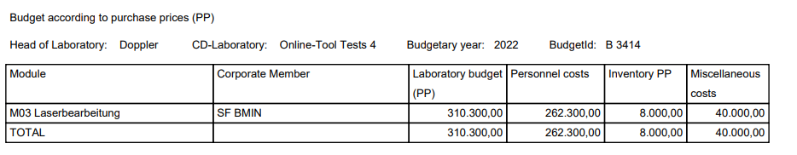

References

Appendix

If applicable:

CV of Head of Laboratory
In case of expansion: If a new area of research is proposed then the CV should show expertise in this field.

